**Q1)**

Some differences between Mongoose and MongoDB packages are:

Mongoose is an Object Data Modeling (ODM) library for MongoDB and Node.js. It manages relationships between data, provides schema validation, and is used to translate between objects in code and the representation of those objects in MongoDB. Whereas MongoDB is a schema-less NoSQL document database. It means you can store JSON documents in it, and the structure of these documents can vary as it is not enforced like SQL databases. This is one of the advantages of using NoSQL as it speeds up application development and reduces the complexity of deployments.

Mongoose will make you code faster with simple apps with simple database structure. And also development time and maintainability in Mongoose is easier as compared to MongoDB. This doesn’t hamper the scalability feature of mongo; because if in future if your app grows and there is a need to add few more fields, you can modify the schema and work accordingly.

CRUD operations using MongoDB native is really faster than mongoose. Following are some examples of basic operations:

**Insert Operation**

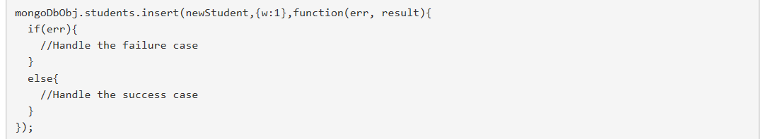

**Update Operation**



**Read Operation**

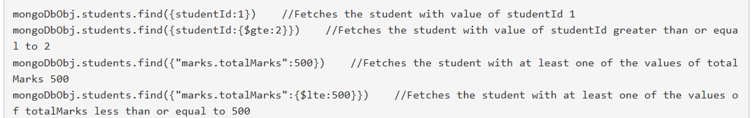

**Delete Operation**



**Q2)**

The POST method is used to submit an entity to the specified resource, often causing a change in state or side effects on the server.

The PUT method replaces all current representations of the target resource with the request payload.

The difference between POST and PUT is that PUT requests are idempotent. That is, calling the same PUT request multiple times will always produce the same result. In contrast, calling a POST request repeatedly have side effects of creating the same resource multiple times.

In order to update data of employees in AJAX application, it is more convenient to use POST method as ajax application uses xml which can further be used to make requests like get, post etc.

**Q3)**

The PUT method replaces all current representations of the target resource with the request payload.

The PATCH method is used to apply partial modifications to a resource.

The major difference between PATCH and PUT, is that PATCH request is non-idempotent and PUT requests are idempotent. That is, calling the same PUT request multiple times will always produce the same result. In PATCH method, you **only apply partial modifications to the resource.**

In order to update a name in the online university application, you should use PATCH, because it does not require to enter the complete entity. You will have to specify only the name in order to update it. Thus, Patch will be more convenient.

**Q4)**

There are two reasons for the shift from AngularJS over to React. First, and the one that triggered interest, is speed. React was *much* faster and more memory efficient than AngularJS. The second reason is more expansive and is what carried React into the stratosphere. Basically, the conception of React is more in-line with where the modern web is going.

React’s architectural concept was also more elegant and easier to understand. React creates a new DOM object and compares it to the old one. Any differences are then rendered to the UI. AngularJS relied on dirty-checking, where every component in the application was checked for changes ten times. It was a huge kluge (rhyming unintentional) and was slow as molasses with large DOMs.

React is very popular today and it is taking over the front-end development. Here is a summary of the reasons why React gained this massive popularity:

* Working with the DOM API is hard. React basically gives developers the ability to work with a virtual browser that is friendlier than the real browser.
* React is just JavaScript. There is a very small API to learn, and after that your JavaScript skills are what make you a better React developer. There are no barriers to entry.

Some advantages of angular js:

1. Easy decision making
2. Component structure
3. Developing environment

Some advantages of reactJs

1. Highly efficient
2. Great user interface

**Example**

React provides a very simple and efficient way to build component trees. Composing your app from React components is like composing a JavaScript program from functions. Just look at the example below, code written in React is logically structured and readable thanks to the availability of components.

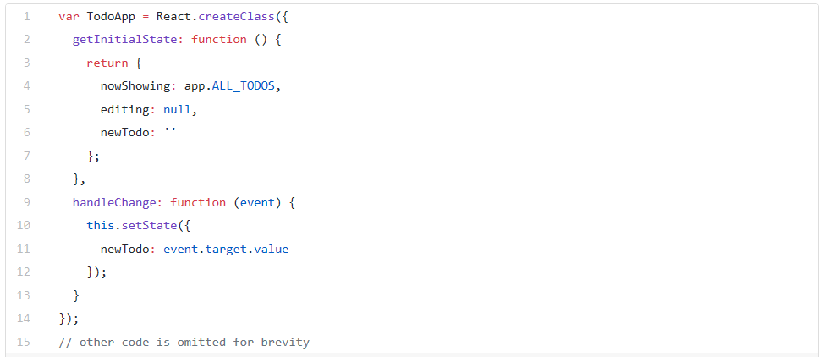

**Q5)**

Vue.js is one of those new software technologies that are being widely used across the world for web development. Vue.js is actually a JavaScript framework with various optional tools for building user interfaces. Its few advantages are:

1. Very small size
2. Easy to understand and develop applications
3. Simple Integration
4. Detailed documentation
5. Flexibility
6. Two way communication

With Angular, its architecture allows automatic and easy data synchronization between the model view and the components. Some of The Major Benefits of AngularJS Web App Development:

1. Angular modular development
2. Angular data binding

For ReactJS, some of the major benefits are:

1. Re-usable components
2. React server-side rendering
3. It also allows the use of JS to write Native IOS applications
4. It provides a separate option for creation of pure JavaScript template.

If we consider Vue.js, there’s a migration helper tool which makes migration easier. But in the large app, it might cause a problem as there is no proper roadmap which focuses on versioning and their plans.

React is more flexible than Angular because Angular is a full framework and React is a set of independent, faster, and evolving libraries, and for that, you have to keep an eye on every little module that is no longer supported or maintained.

**The infamous counter example**

Here is the comparison

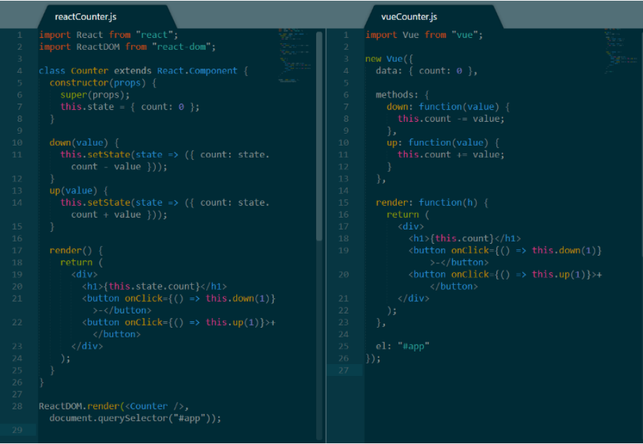

**Q6)**

AngularJS is an open-source, JavaScript-based, front-end web application framework for dynamic web app development. It utilizes HTML as a template language. By extending HTML attributes with directives and binding data to HTML with expressions, AngularJS creates an environment that is readable, extraordinarily expressive and quick to develop. Whereas, Angular is the blanket term used to refer to Angular 2, Angular 4 and all other versions that come after AngularJS. Both Angular 2 and 4 are open-source, TypeScript-based front-end web application platforms. Some advantages of all versions are discussed as:

**1. AngularJS Advantages**

* It is unit testing ready.
* It has great MVC data binding makes app development fast.
* Using HTML as a declarative language makes it very intuitive.
* It is a comprehensive solution for rapid front-end development since it does not need any other frameworks or plugins.
* AngularJS apps can run on every significant program and advanced cells including iOS and Android-based phones and tablets.

**2. Angular 2 Advantages**

* TypeScript allows code optimization using the OOPS concept.
* It is mobile-oriented.
* It has improved dependency injection and modularity.
* It provides more choice for languages such as Dart, TypeScript, ES5, and ES6 for writing codes.
* It offers simpler routing.

**3. Angular 4 Advantages**

* It enables a fast development process.
* It’s ideal for single-page web applications with an extended interface.
* Full TypeScript support helps in building bulky applications.
* Tests are easy to write.
* An improved View Engine generates less code in AOT mode.
* It has a modularized animation package.

Each version of Angular has significant benefits, but there is much to gain in being up-to-date with the latest version. Angular is decidedly faster than AngularJS, has a mobile-driven approach, executes better with components, and enables smoother migration from earlier versions. If you are comfortable with one version of Angular, switching to another should be easy for you—and well worth the effort.

**Q7)**

**Linting** means running a very basic code quality tool which will look at JavaScript code and tells where and how to clean it up. In other words, it automatically find the mistakes and fixes them. It makes code break less and prevent some very confusing problems. Linting is a vital part of the workflow and will help you improve your skills.

**Uses of JSLint**

* It prevents certain types of bugs, including a few catastrophic ones.
* It saves time.
* It makes code readable.
* It is user-friendly and configurable.
* It is pretty common and has a good amount of community support.
* Finding (syntax) errors before execution

**Uses of ESLint**

ESLint is a linter for the JavaScript programming language, written in Node js. It is hugely useful because JavaScript, being an interpreted language, does not have a compilation step and many errors are only possibly found at runtime. It helps to:

* avoid infinite loops in the for loop conditions
* make sure all getter methods return something
* disallow console.log (and similar) statements
* check for duplicate cases in a switch
* check for unreachable code
* check for JSDoc validity

**Example**

SublimeLinter is a plugin for Sublime Text that provides a framework for linting code.

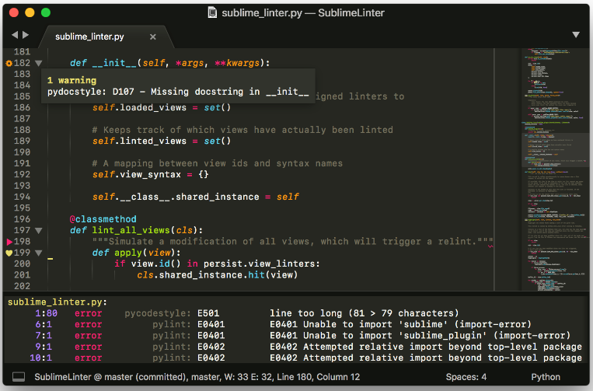

**Q8)**

Ajax is the feature which allows you to update the part of the page without update or refresh the page while AngularJS is one of the JavaScript (to be specific) client side MVC framework. AJAX is a way to communicate (send requests and get responses) with the server without refreshing that is asynchronously. AngularJS is a full-fledge front end MVC framework which does a lot more. It extends the $http module with a lot of neat features such as 2-way data binding, templating, filters and directives etc.

Facebook, Gmail, and Pinterest are examples of sites that use a lot of AJAX. AJAX calls will be preferred in the scenario:

* Client requests page from server
* Server responds to request and sends page
* Client makes AJAX call to the server and requests more data
* Server sends that data.
* Client updates the page using that data without refreshing.

Angular is preferred in:

* When you are dealing with SPA.
* When a component needs to be refreshed instead of complete page.
* When building big websites.
* When you have two way binded applications.